
Docusign Envelope ID: DDE1DB8B-7254-4BCF-8319-E89351B1627A

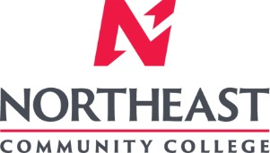
Associate to Bachelors (A2B) Articulation Agreement
Prescribed Curriculum: Northeast Community College

Associate of Science – Engineering (Metallurgical)

General Education Courses |  |  |  | 34 CREDIT HOURS
 | Credit Hours | Course No. | Course Title or Category
Written Comm | 3 | ENGL 2070, or  ENGL 1010 | Technical Communications I  English Composition I
Oral Communication | 3 | SPCH 1010 or 1110 | Fundamentals of Communication or Public Speaking
Behavioral & Social Sciences | 3 | Select 1 course from | AS General Education list, except AGRI 1530
English/Literature | 3 | Select 1 course from | AS General Education list, except ENGL 1020
Fine Arts and  Language | 3 | Select 1 course from | AS General Education list
Mathematics | 10 | MATH 1600  MATH 2010 | Analytic Geometry and Calculus I Analytic Geometry and Calculus II
Natural Science | 9 | CHEM 1090  PHYS 2110 | General Chemistry I  General Physics I w/Calculus

Required Courses |  |  | 19 CREDIT HOURS
 | Credit Hours | Course No. | Course Title
Mathematics, Science, & Engineering | 5 | MATH 2020 | Analytic Geometry and Calculus III
Mathematics, Science, & Engineering | 3 | MATH 2100 | Differential Equations
Mathematics, Science, & Engineering | 5 | PHYS 2120 | General Physics II with Calculus
Mathematics, Science, & Engineering | 3 | ENGR 1010 | Introduction to Engineering Design
Mathematics, Science, & Engineering | 3 | ENGR 2020 | Engineering Statics

Program Elective Courses |  |  | 7 CREDIT HOURS
 | Credit Hours | Course No. | Course Title
Program Course | 4 | CHEM 1100 | General Chemistry II
Electives | 3 | ENGR 1020 | Programming and Problem Solving

Associate of Science – Engineering (Metallurgical) Total: | 60 CREDIT HOURS

Post-Associate Degree Prescribed Curriculum: South Dakota Mines

Bachelor of Science – Metallurgical Engineering

General Education Courses |  |  |  | 6 CREDIT HOURS
 | Credit Hours | Course No. | Course Title or Category
Written Communication | 3 | ENGL 289 | Explorations in STEM Communications
Social Sciences | 3 | Select 1 course from | Social Sciences (Goal 3) list

Major Required Courses |  |  | 43 CREDIT HOURS
 | Credit Hours | Course No. | Course Title
Metallurgical Engineering | 4 | MET 231/232 | Structures and Properties of Materials w/Lab
Metallurgical Engineering | 4 | MET 220/220L | Mineral Processing and Resource Recovery w/Lab
Metallurgical Engineering | 4 | MET 320 | Metallurgical Thermodynamics
Metallurgical Engineering | 1 | MET 333 | Process Measurements and Control
Metallurgical Engineering | 4 | MET 422 | Transport Phenomena
Metallurgical Engineering | 4 | MET 321/321L | High Temp Extraction, Concentration, and Recycling w/Lab
Metallurgical Engineering | 2 | MET 352 | Principles of Metallurgical Design
Metallurgical Engineering | 4 | MET 330/330L | Physics of Metals w/Lab
Metallurgical Engineering | 3 | MET 332 | Thermomechanical Processing
Metallurgical Engineering | 2 | MET 464 | Senior Design I
Metallurgical Engineering | 4 | MET 310/310L | Aqueous Extraction, Concentration, and Recycling w/Lab
Metallurgical Engineering | 2 | MET 433 | Process Control
Metallurgical Engineering | 4 | MET 440/440L | Mechanical Metallurgy w/Lab
Metallurgical Engineering | 1 | MET 465 | Senior Design II

Other Required Courses |  |  | 12 CREDIT HOURS
 | Credit Hours | Course No. | Course Title
Mathematics | 3 | MATH 373 | Introduction to Numerical Analysis
Other Engineering | 3 | Select 1 course from | EM 321 (Mechanics of Materials) or ME 216 (Solid Mechanics)
Other Engineering | 4 | EE 301/301L | Introduction to Circuits, Machines, and Systems w/Lab
Economics | 2 | IENG 301 | Basic Engineering Economics

Elective Courses |  |  | 9 CREDIT HOURS
 | Credit Hours | Course No. | Course Title
Major Electives | 6 | Select with Advisor | Major electives
UD Humanities /  Social Science | 3 | Select with Advisor | Upper Division Humanities or Social Science elective

Post-Associate Degree Total: | 70 CREDIT HOURS

Bachelor of Science – Metallurgical Engineering Total: | 130 CREDIT HOURS

A2B Articulation Agreement Guarantees & Limitations

GUARANTEES

Students who:
- complete the Associate of Science – Pre-Engineering degree prescribed curriculum at Northeast Community College exactly as it is identified in this articulation agreement, and
- have the degree conferred on their education record at Northeast Community College (post high school graduation), and
- earn a minimum cumulative grade point average (GPA) of 2.75 at the Northeast Community College, and
- pass all 60 credits for the associate degree, earning a grade C- or higher in each course

are guaranteed the following at the South Dakota School of Mines and Technology (South Dakota Mines):
- junior standing at South Dakota Mines with no more than 70 remaining credits to meet the graduation requirements for the Bachelor of Science degree in Metallurgical Engineering.
- admission to South Dakota Mines
- admission to the Bachelor of Science degree in Metallurgical Engineering.

LIMITATIONS
- This agreement is between the Associate of Science – Pre-Engineering degree at Northeast Community College and the Bachelor of Science degree in Metallurgical Engineering at South Dakota Mines only.
- Students must meet all admission and application requirements at South Dakota Mines, including the submission of all required documentation by stated deadlines. Students are advised to contact the Office of Admissions at the South Dakota Mines early in their transfer planning.
- Student must have a cumulative grade point average (GPA) at the Northeast Community College of 2.75 or higher
and only courses with grades of C- or higher are guaranteed to be accepted in transfer by South Dakota Mines.
- The credit and course transfer guarantees described in this agreement apply to the Associate of Science – Pre- Engineering degree at Northeast Community College and the Bachelor of Science degree in Metallurgical Engineering at South Dakota Mines. If the student changes majors at Northeast Community College or at South Dakota Mines, the student is no longer covered by this Articulation Agreement and none of the Guarantees of the Agreement apply.
- Students utilizing any form of transfer credit, including but not limited to credit awarded from other higher education institutions, standardized exam (CLEP, AP, DSST, etc.), prior learning assessment (military, certifications, ACE recommended credit, portfolio, challenge exam, work experience equivalent credit, etc.) to satisfy any Associate degree requirements will have those credits evaluated by South Dakota Mines. Should South Dakota Mines not accept the transfer credits accepted by Northeast Community College, the student will be required to make up the credit deficiency at South Dakota Mines.
- No course substitutions are allowed for the courses listed in the Prescribed Curriculum for the associate degree at Northeast Community College.

A2B CONTACT INFORMATION
South Dakota Mines Northeast Community College
Office of the Provost Registration Office
605.394.2256 402.844.7265
Provost@sdsmt.edu

RENEWAL, REVISION, and TERMINATION
- This Associate to Bachelor Articulation Agreement (A2B) shall be in effect July 1 – June 30 each year and will automatically renew annually unless action is taken by South Dakota Mines or Northeast Community College to terminate or modify it.
- The South Dakota Mines Office of the Provost and the Northeast Community College Academic Affairs division will collaborate to coordinate a review of the content of the associate and bachelor degrees on a three-year cycle to ensure this A2B is still appropriate.
- South Dakota Mines and the Northeast Community College each reserve the right to seek revision of this agreement at any time.
- Revision of any content of the agreement (except Appendices content) will be approved by each institution and result in a new agreement being signed, with copies retained by each institution.
  - Revision to any Appendices will be communicated to each institution, but do not need to be approved by each institution and will not result in a new agreement being signed by each institution.
- South Dakota Mines and the Northeast Community College each reserve the right to seek termination of this agreement at any time.
- Should the agreement be terminated, each institution agrees to collaborate and engage in appropriate plans to notify and work with impacted students, providing a minimum one-year advance notice of termination.

APPROVALS

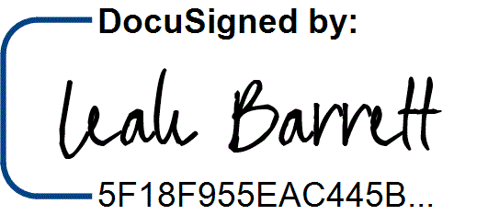
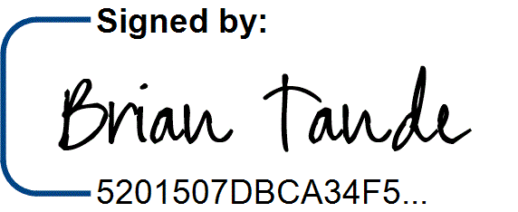
7/29/2025 7/28/2025
Brian Tande, Ph.D. Date Leah Barrett, Ed.D. Date President President
South Dakota Mines Northeast Community College
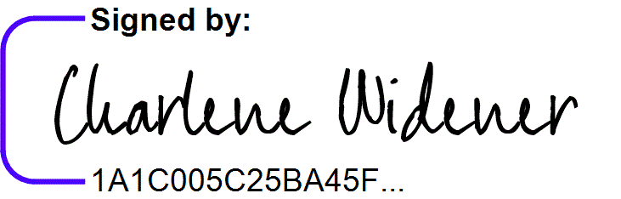
Brian.Tande@sdsmt.edu lbarrett@northeast.edu

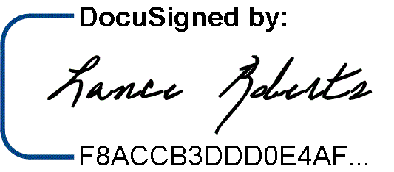
7/29/2025
7/25/2025

Lance Roberts, Ph.D. Date Charlene Widener, Ph.D. Date Provost and Vice President for Academic Affairs Vice President of Educational Services
South Dakota Mines Northeast Community College
Lance.Roberts@sdsmt.edu cwidener@northeast.edu

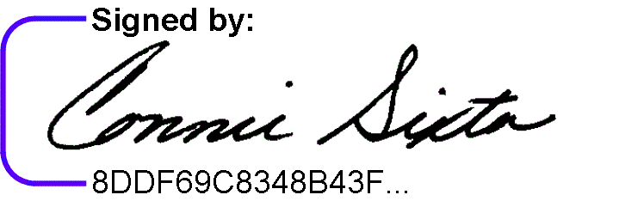
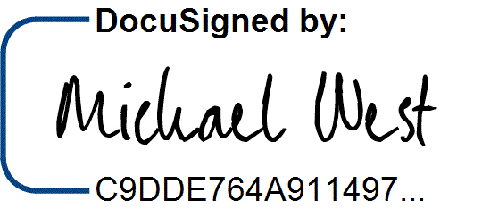
7/28/2025 7/25/2025
Michael West, Ph.D. Date Connie Sixta Date Department Head Dean of Science, Technology, Agriculture & Math
South Dakota Mines Northeast Community College
Michael.West@sdsmt.edu connie@northeast.edu

Appendix A: Course Sequence


Course Sequence: Northeast Community College

Pre-Engineering - Metallurgical (A.S.)

Semester | Course No. | Course Title | Credit Hours | Completed
Freshman | ENGL 2070 | Technical Communications I (or ENGL 1010 English Comp I) | 3
Year
Year | MATH 1600 | Analytic Geometry and Calculus I | 5
First
First | CHEM 1090 | General Chemistry I | 4
Semester
Semester | ENGR 1010 | Introduction to Engineering Design | 3
 |  | Total Credits | 15

Semester | Course No. | Course Title | Credit Hours | Completed
Freshman | Select 1 course from | General Education: English/Literature (Except ENGL 1020) | 3
Year
Year | MATH 2010 | Analytic Geometry and Calculus II | 5
Second
Second | PHYS 2110 | General Physics I with Calculus | 5
Semester
Semester | CHEM 1100 | General Chemistry II | 4
 |  | Total Credits | 17

Semester | Course No. | Course Title | Credit Hours | Completed
Sophomore | PHYS 2120 | General Physics II with Calculus | 5
Year
Year | ENGR 2020 | Engineering Statics | 3
First
First | MATH 2100 | Differential Equations | 3
Semester
Semester | Select 1 course from | General Education: Behavioral/Social Sci (Except AGRI 1530) | 3
 |  | Total Credits | 14

Semester | Course No. | Course Title | Credit Hours | Completed
Sophomore | Select 1 course from | General Education: Fine Arts and Language | 3
Year
Year | MATH 2020 | Analytic Geometry and Calculus III | 5
Second
Second | Select 1 course from | SPCH 1010 Fund of Comm or SPCH 1110 Public Speaking | 3
Semester
Semester | ENGR 1020 | Programming and Problem Solving | 3
 |  | Total Credits | 14

General Education Coursework Total:  Major and Elective Coursework Total:  Northeast Community College Coursework Total: | 34 credit hours  26 credit hours  60 CREDIT HOURS

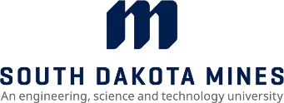
Course Sequence: South Dakota Mines – Fall Semester Start

Metallurgical Engineering (B.S.) – even year start

Semester | Course No. | Course Title | Credit Hours | Completed
Junior Year First Semester  - FALL | MET 231 | Properties of Materials Lab | 1
Junior Year First Semester  - FALL | MET 232 | Properties of Materials | 3
Junior Year First Semester  - FALL | MET 320 | Metallurgical Thermodynamics | 4
Junior Year First Semester  - FALL | MET 422 | Transport Phenomena | 4
Junior Year First Semester  - FALL | Select 1 course from | Social Science (Goal 3) - Civics CIV 100, HIST 151, HIS 152,  POLS 100, or POLS 210 | 3
Junior Year First Semester  - FALL | ENGL 289 | Explorations in STEM Communications* | 3
Total Credits 18

Semester | Course No. | Course Title | Credit Hours | Completed
Junior Year | MET 220/220L | Mineral Processing and Resource Recovery w/lab | 4
Second
Second | MET 321/321L | High Temperature Extraction, Concentration, & Rec w/lab | 4
Semester -
Semester - | MET 352/352L | Principles of Metallurgical Design w/lab | 2
SPRING
SPRING | MATH 373 | Introduction to Numerical Analysis | 3
 | Select 1 course from | ME 216 Solid Mechanics or EM 321 Mechanics of Materials | 3
 | IENG 301 | Basic Engineering Economics | 2
 |  | Total Credits | 18

Semester | Course No. | Course Title | Credit Hours | Completed
Senior Year First Semester  - FALL | MET 333 | Process Measurements and Control | 1
Senior Year First Semester  - FALL | MET 464 | Senior Design | 2
Senior Year First Semester  - FALL | MET 330/330L | Physics of Metals w/lab | 4
Senior Year First Semester  - FALL | MET 332 | Thermomechanical Processing | 3
Senior Year First Semester  - FALL | EE 301/301L | Introduction to Circuits, Machines and Systems w/Lab | 4
Senior Year First Semester  - FALL |  | Major Electives | 3
Total Credits 17

Semester | Course No. | Course Title | Credit Hours | Completed
Senior Year | MET 310/310L | Aqueous Extraction, Concentration, and Recycling w/lab | 4
Second
Second | MET 440/440L | Mechanical Metallurgy w/lab | 4
Semester -
Semester - | MET 433 | Process Control | 2
SPRING
SPRING | MET 465 | Senior Design II | 1
 |  | Major Electives | 3
 |  | Upper Division Humanities or Social Science Elective | 3
 |  | Total Credits | 17

General Education Coursework Total:  Major and Elective Coursework Total:  South Dakota Mines Coursework Total: | 6 credit hours  64 credit hours  70 CREDIT HOURS

Course Sequence: South Dakota Mines – Fall Semester Start

Metallurgical Engineering (B.S.) – odd year start

Semester | Course No. | Course Title | Credit Hours | Completed
Junior Year First Semester  - FALL | MET 231 | Properties of Materials Lab | 1
Junior Year First Semester  - FALL | MET 232 | Properties of Materials | 3
Junior Year First Semester  - FALL | MET 320 | Metallurgical Thermodynamics | 4
Junior Year First Semester  - FALL | ENGL 289 | Explorations in STEM Communications* | 3
Junior Year First Semester  - FALL | Select 1 from | ME 216 Solid Mechanics or EM 321 Mechanics of Materials | 3
Total Credits 14

Semester | Course No. | Course Title | Credit Hours | Completed
Junior Year | MET 220/220L | Mineral Processing and Resource Recovery w/lab | 4
Second
Second | MET 310/310L | Aqueous Extraction, Concentration, and Recycling w/lab | 4
Semester -
Semester - | MET 440/440L | Mechanical Metallurgy w/lab | 4
SPRING
SPRING | MET 352/352L | Principles of Metallurgical Design w/lab | 2
 |  | Total Credits | 14

Semester | Course No. | Course Title | Credit Hours | Completed
Senior Year First Semester  - FALL | MET 333 | Process Measurements and Control | 1
Senior Year First Semester  - FALL | MET 422 | Transport Phenomena | 4
Senior Year First Semester  - FALL | MET 464 | Senior Design | 2
Senior Year First Semester  - FALL | IENG 301 | Basic Engineering Economics | 2
Senior Year First Semester  - FALL | MATH 373 | Introduction to Numerical Analysis | 3
Senior Year First Semester  - FALL | Select 1 course from | Social Science (Goal 3) - Civics CIV 100, HIST 151, HIS 152,  POLS 100, or POLS 210 | 3
Total Credits 15

Semester | Course No. | Course Title | Credit Hours | Completed
Senior Year | MET 321/321L | High Temperature Extraction, Concentration, & Rec w/lab | 4
Second
Second | MET 433 | Process Control | 2
Semester -
Semester - | MET 465 | Senior Design II | 1
SPRING
SPRING | EE 301/301L | Introduction to Circuits, Machines & Systems w/Lab | 4
 |  | Major Elective | 3
 |  | Total Credits | 14

Semester | Course No. | Course Title | Credit Hours | Completed
Senior Year | MET 330/330L | Physics of Metals w/lab | 4
Third
Third | MET 332 | Thermomechanical Processing | 3
Semester -
Semester - |  | Major Elective | 3
FALL
FALL |  | Upper Division Humanities or Social Science Elective | 3
 |  | Total Credits | 13

General Education Coursework Total:  Major and Elective Coursework Total:  South Dakota Mines Coursework Total: | 6 credit hours  64 credit hours  70 CREDIT HOURS

